Better Health Tai Chi Chuan Inc.
ARBN Y2072442
A non-profit organisation

To provide
an enjoyable
and supportive
environment
for all to learn
and to grow through
Tai Chi Chuan.

6 Fisher Place
Narwee NSW 2009

Phone
02 9533 6511

Fax
02 9534 4211

Email
info@betterhealthtcc.com.au

Web
www.betterhealthtcc.com.au

All forms of contribution
to the BHTCC Newsletter are
very welcome.

This newsletter has been compiled and written by Philo Kaarma
Contact: Philomena.kaarma@gmail.com

Better Health Tai Chi Chuan is a non-profit organisation aims to provide an enjoyable and supportive environment for all to learn and to grow through Tai Chi Chuan

Welcome to 2012 Term 3
THE YEAR OF THE DRAGON



Better Health Tai Chi Chuan
Classes for 2012
New Enrolments: any Tuesday evenings between Feb - Oct. at 6.30 pm
Venue: St George Girls High School
at the new gym, Victoria St., Kogarah, 2217
(Entrance via Harrow Road)
Time: 7.00 - 8.00 pm and 8.00 - 9.00 pm Tuesday

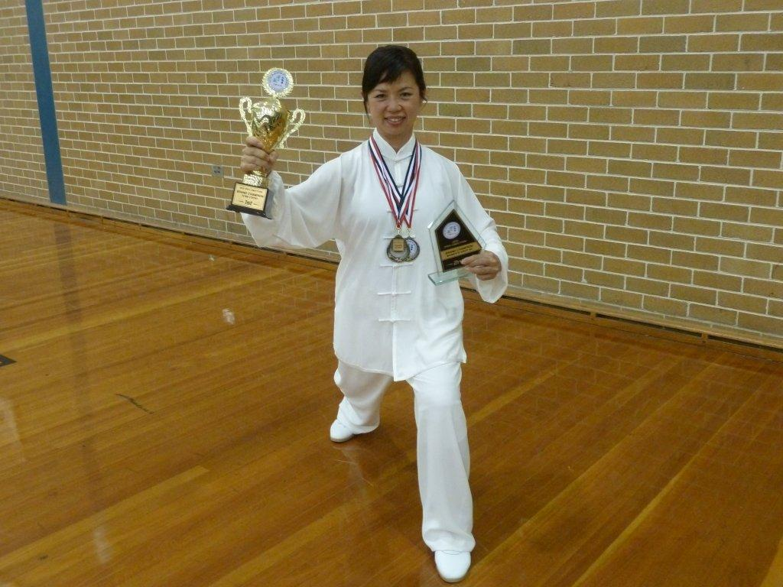

Congratulation to Serene Yong Harris

!

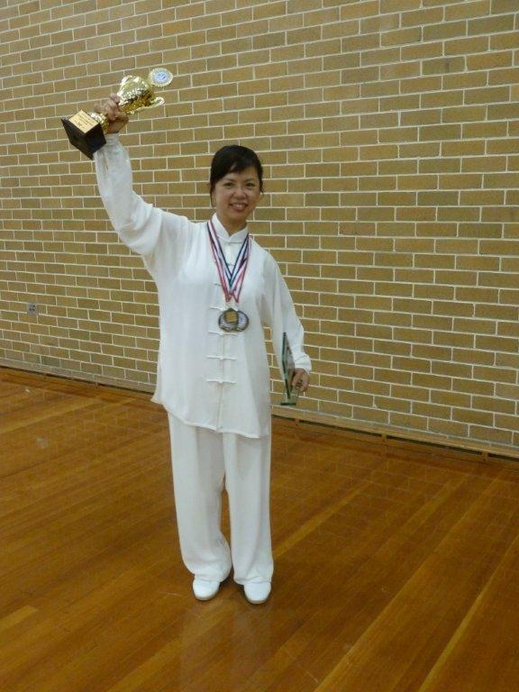

Serene Yong Harris pictured at the Open Tai Chi Competition

The Tai Chi Association of Australia together with the University of Sydney Confucius Institute held an Open Tai Chi Competition at the Sydney University on Saturday 9th June 2012.

This event was well patronised by competitors and spectators alike. The BHTCC was represented by a large contingent to support tai chi as well as support our BHTCC instructor Serene Yong Harris. It was a great day for tai chi, a very well organised competition and it was very interesting to see the different styles/forms of tai chi and the different levels.

Serene won the following medals:
2 gold medals for the individual events (Bare Hands), runner up for 42 Swords, Champion in the Group Event and 2nd place for the Grand Champion Title for Women’s Over 45 Division.

Serene and has specifically asked the following to be mentioned .............

“I like to thank all those who have taken the trouble to go down Sydney University to support the TCAA Tai Chi Competition on the 9th June and to cheer for me. I was quite surprised that more than 10 people from BHTCC were there & some with your partners, THANK YOU VERY MUCH!”

To which I would like to add: I thoroughly enjoyed the day and thoroughly enjoyed being a part of the winners from BHTCC show fellowship and enjoying the day with friends with a common interest.

I have taken the liberty of quoting Torben Rif from Taiji Europa, a tai chi practitioner on his comments of tai chi competition.

It is a great experience for all concerned! It is also dependent on the type of competition. A well intended and conducted competitions share tai chi good spirits. There are both positive and negative aspects to practicing taijiquan as competitive sport. I have often heard it said that the competitions are destroying taijiquan, and that those who compete aren´t doing real taijiquan. Having actively participated in taiji competitions as a competitor, a referee and as an organiser, I can confirm that it has certainly helped to improve my taijiquan. In every competition I’ve entered I have trained much harder than I would normally train and I’ve also had more correction and feedback for my performance. Torben Rif – Taiji Europa.

What do you think?

Classes 2012

Tuesday Nights
7.00 pm – 8.00 pm
Tai Chi for Health programs including Tai Chi for Arthritis, Tai Chi for Energy and Tai Chi for Diabetes.
Yang Style 24 Forms
Yang Style 40 Forms

8.00pm – 9.00pm
The Combined 42 Forms
The 42 Sword Forms

Venue:
St George Girls High School
at the new gym, Victoria St., Kogarah, 2217
(Entrance via Harrow Road)

http://www.taichiforhealthinstitute.org/newsletter/

http://www.betterhealthtcc.com.au/index.htm

http://www.taichiforhealthinstitute.org/newsletter/

Tai chi information, instructional DVDs, books and workshops by Dr Lam from Tai Chi Productions.
- A full range of instructional tai chi DVDs, books and CDs produced by Dr Lam. >>more
Ask Dr Lam any tai chi questions, click here.
A forum to share your thoughts and experience with other tai chi enthusiasts, click here.
- You can learn more about tai chi from a comprehensive range of tai chi articles, and free monthly newsletter.

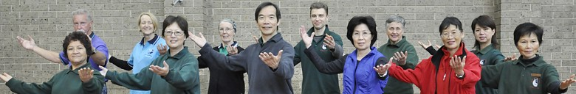
BHTCC AT WORK

Tai chi show is out of this world Tai Chi in space
Thursday, June 28, 2012
Astronaut Liu Wang is China's first woman in space. But she can probably claim another first - for tai chi in space.


Tai Chi in space: China's first female astronaut, Liu Yang, performs a Tai Chi routine during a night shift on the Tiangong - 1 Space Lab Module. Regular exercise is crucial for astronauts in space. After finishing her tasks aboard the Tiangong-1 orbiter on Tuesday night, 33-year-old Liu had another mission to complete, a tai chi performance. Liu, after speaking with ground control, strapped down her feet and began some warm-up exercises. She then did three minutes of tai chi, with CCTV calling her performance "gentle and natural."
Tai chi is a great stress buster and also provides physical exercise. The program was specially designed for the three-person mission crew, who have already been in space for 10 days, by their physical training instructor. Instructor Tong Feizhou told CCTV: "Performing tai chi is to regulate their breathing and relax their body and muscles and bones." She said all the astronauts enjoy performing tai chi when they have spare time - even when they are barreling along 340 kilometers above the Earth.
_________________________________________________________________________________

FIRST LOOK for those with You Tube access .................................................

http://www.firstshowing.net/2012/watch-cool-behind-the-scenes-look-at-keanu-reeves-man-of-tai-chi/

Watch: Cool Behind the Scenes Look at Keanu Reeves' 'Man of Tai Chi'
Here's the behind-the-scenes look at Keanu Reeves' Man of Tai Chi from Twitch for those who have access to You Tube
by Ethan Anderton
June 22, 2012 Source: Twitch

Last August we learned that Keanu Reeves' directorial debut Man of Tai Chi, in which The Matrix star will also appear in as the villain, had finally rounded up financing. The plot of the film isn't known yet, but Reeves has said it will have tons of kung fu fighting, maybe as many as 18 fights totaling 40 minutes of screen time. And now we have a cool glimpse at how they're going to capture some of these fight scenes. A behind the scenes video of Reeves getting ready to shoot by testing out a motion-control camera called Iris from the company Bot & Dolly, that looks to make for some pretty impressive cinematography. Watch it!
Did you know: Better Health Tai Chi Chuan is a non-profit organisation aims to provide an enjoyable and supportive environment for all to learn and to grow through tai chi.
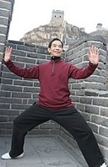
Chief Instructor:
Dr Paul Lam
Dr Paul Lam, a practicing physician and tai chi expert for 30 years, is a world leader in the field of tai chi for health improvement. He is a past gold medalist in the third international Tai Chi competition (Beijing 1993) and has trained thousands of tai chi instructors around the world. Dr Lam has written and produced several best-selling books and instructional DVDs. Click to visit Dr Lam's Tai Chi for Health Institute, or production website for tai chi instructional material, to ask Dr Lam any tai chi question or subscribe his monthly newsletter.
Why learn from us?
- Your one fee entitles you to attend all our classes. You will find learning with us easy and fun. Our friendly and helpful instructors and members will make you feel welcome. Instructors are accredited by the Australian Coaching Council.
- We are a registered non-profit organisation, your fee will be used for the benefit of tai chi.
Our Goals:
- Provide quality instructions to all levels of ability Motivate and assist all to reach their full potential in tai chi Encourage long term practice of tai chi to improve health Promote benefits of tai chi to the wider community Stay true to fundamental tai chi principles
- Further develop the art of tai chi
Dr Paul Lam gave one his wonderful talks at the end of our class last week (this is why Better Health Tai Chi in Sydney is so lucky!!) he also mentioned his newsletter. Some of our class have asked for Paul’s website link so they can access his monthly newsletter (highly recommended reading).

You can read Dr Paul Lam’s newsletter using the following link [Control click to follow link] for the Tai Chi for Health Institute. http://www.taichiforhealthinstitute.org/

The website and now the Facebook page has loads of information about tai chi and all of Dr Paul Lam’s DVDs are also listed. Click on and discover the best website for tai chi.
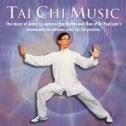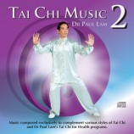Have you heard these CDs?? The most gorgeous music to complete your tai chi. Click on the website http://www.taichiforhealthinstitute.org/ and organise to purchase these and other CDs and DVDs



It is not to late to show your interest in attending the following workshops

CALENDAR - Workshops by Dr Paul Lam

INDIVIDUAL WORKSHOP
July 7 - July 8, 2012.
Sydney, NSW, Australia.
Exploring the Depth of Tai Chi for Arthritis

INDIVIDUAL WORKSHOP
July 21 - July 22, 2012.
Sydney, NSW, Australia.
Tai Chi for Energy Instructor Training

Location

St. George Girls High School
Victoria Road
Kogarah NSW 2217
Entrance via Harrow Road

Workshop Time

9.00 am to 5.00 pm

Contact

Tai Chi for Health Institute
6 Fisher Place
Narwee NSW 2209
Anna Bennett
Phone: 9533 6511
Email: manager@taichiforhealthinstitute.org

Journal http://medicalxpress.com/news/2012-06-tai-chi-brain-size-benefits.html reference: Journal of Alzheimer's Disease

Tai Chi increases brain size, benefits cognition in randomized controlled trial of Chinese elderly
June 19, 2012 in Health
Scientists from the University of South Florida and Fudan University in Shanghai found increases in brain volume and improvements on tests of memory and thinking in Chinese seniors who practiced Tai Chi three times a week, reports an article published today in the Journal of Alzheimer's Disease.
Findings were based on an 8-month randomized controlled trial comparing those who practiced Tai Chi to a group who received no intervention. The same trial showed increases in brain volume and more limited cognitive improvements in a group that participated in lively discussions three times per week over the same time period.
Previous trials have shown increases in brain volume in people who participated in aerobic exercise, and in one of these trials, an improvement in memory was seen. However, this was the first trial to show that a less aerobic form of exercise, Tai Chi, as well as stimulating discussion led to similar increases in brain volume and improvements on psychological tests of memory and thinking.
The group that did not participate in the interventions showed brain shrinkage over the same time period, consistent with what generally has been observed for persons in their 60s and 70s.
Numerous studies have shown that dementia and the syndrome of gradual cognitive deterioration that precedes it is associated with increasing shrinkage of the brain as nerve cells and their connections are gradually lost.
"The ability to reverse this trend with physical exercise and increased mental activity implies that it may be possible to delay the onset of dementia in older persons through interventions that have many physical and mental health benefits," said lead author Dr. James Mortimer, professor of epidemiology at the University of South Florida College of Public Health.
Research suggests that aerobic exercise is associated with increased production of brain growth factors. It remains to be determined whether forms of exercise like Tai Chi that include an important mental exercise component could lead to similar changes in the production of these factors. "If this is shown, then it would provide strong support to the concept of "use it or lose it" and encourage seniors to stay actively involved both intellectually and physically," Dr. Mortimer said.
One question raised by the research is whether sustained physical and mental exercise can contribute to the prevention of Alzheimer's disease, the most common dementing illness.
"Epidemiologic studies have shown repeatedly that individuals who engage in more physical exercise or are more socially active have a lower risk of Alzheimer's disease," Dr. Mortimer said. "The current findings suggest that this may be a result of growth and preservation of critical regions of the brain affected by this illness."
More information: James A. Mortimer, Ding Ding, Amy R. Borenstein, Charles DeCarli, Qihao Guo, Yougui Wu, Qianhua Zhao, Shugang Chu. Changes in Brain Volume and Cognition in a Randomized Trial of Exercise and Social Interaction in a Community-Based Sample of Non-Demented Chinese Elders, Journal of Alzheimer’s Disease 2012; 30 (4), published by IOS Press.

